Data Communication between LWC Components
There are three types of communication between LWC Components:

- Parent to Child Communication
- Child to Parent Communication
- Communication between unrelated components

1. Parent to Child Communication
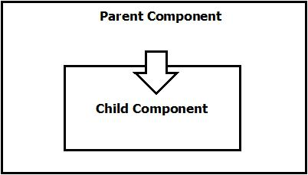
It is done by public properties using @api decorator.

2. Child to Parent Communication
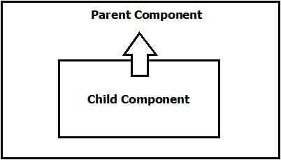
It is done by Custom Event.

3. Communication between unrelated components
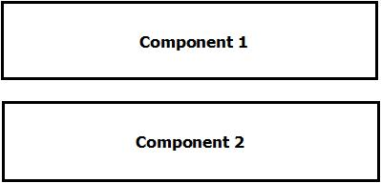

It is done by Lightning Message Service (LMS).

